Name ________________________ HOMEWORK Nov.29-Dec.3
Module 4 Week 2
Put your initials by each night that your child practiced the following:
____ Monday ____Tuesday ____Thursday
*Nightly Homework*
1. Count numbers 1-50.
2. Practice assigned Sight Word list in red reading folder.

MONDAY-Identify the medial sound /o/. Color the picture if it has the same middle sound as in mop?
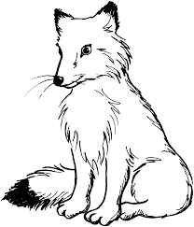  fox | cap | 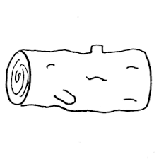  log | dip | cub

Trace and practice forming the letters.
O o O o O o ______

TUESDAY-Circle the pictures that have the short o sound with a red crayon and circle the pictures with a long o sound with a yellow crayon.

dot | 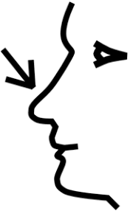  nose | box | 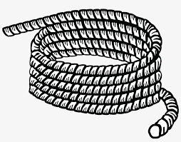  rope | boat | mop

Read it. Trace it. Write it.
bam bam ____ nap nap ____
ran ran ____ rat rat ____
THURSDAY-
Identify medial sounds. Color the happy face if the pictures have the same medial sound as pot. Color the sad face if the words do not have the same medial sound as pot.
log mop

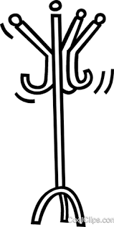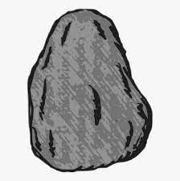
rack rock

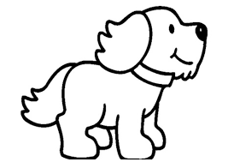
dog pot

Circle the word that rhymes with the given picture.
 | got sob fox
 | hop hen pet
 | dot pop cab
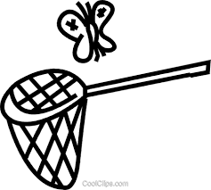 | set pan cat

Start Right Reader Module 4 Week 2
Words to Know
on
of
here
got

Bob Tips a Pot
“Put the pot here, Tom, on top of the bin.” “Got it, Mom!” “Bob! Bob! Not in here, Bob!” Bob got on top of the bin. Bob taps the pot. It tips! “Can you mop it, Tom? Bob is a tot.” “Got it, Mom.” Bob ran to Tom. “Mom! Mom! Bob can mop!”

